Project Design Phase
Solution Architecture

Date | 15 February 2025
Team ID | LTVIP2026TMIDS55906
Project Name | Strategic product placement analysis:unveiling sales impact with tableau visualization
Maximum Marks | 4 Marks

Solution Architecture:
Solution architecture is a complex process – with many sub-processes – that bridges the gap between business problems and technology solutions. Its goals are to:
- Integrate sales and store layout data into a unified analytical system.
- Use Tableau dashboards to visually analyze product placement effectiveness.
- Provide interactive filters and comparison views to evaluate before–after placement impact.
- Generate automated insights and reports to support data-driven decision-making.
Product placement analysis system diagram :
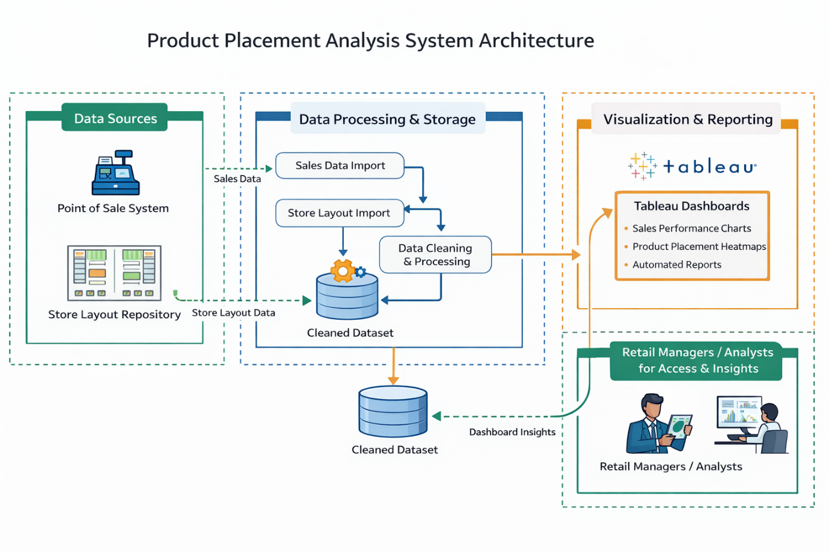
Figure 1: Product placement analysis system diagram
Reference: https://aws.amazon.com/blogs/industries/voice-applications-in-clinical-research-powered-by-ai-on-aws-part-1-architecture-and-design-considerations/

